Bahria University,

Karachi Campus

LAB EXPERIMENT NO.

**03**

LIST OF TASKS

|  |  |
| --- | --- |
| TASK NO | OBJECTIVE |
|  |  |
| 1 | Print square of any integer in the range 1-31. |
| 2 | Write a VVM program which take an integer input and display table of that integer. |
| 3 | Print number until the number is positive. |

Submitted On:

(Date: DD/MM/YY)

**Task No 1:** Print square of any integer in the range 1-31.

**Input:**

in

sto 99

lda 98

add 99

sto 98

lda 97

add 96

sto 97

sub 99

brz 11

br 02

lda 98

out

hlt

*96

dat 001

dat 000

dat 000

**Output:**

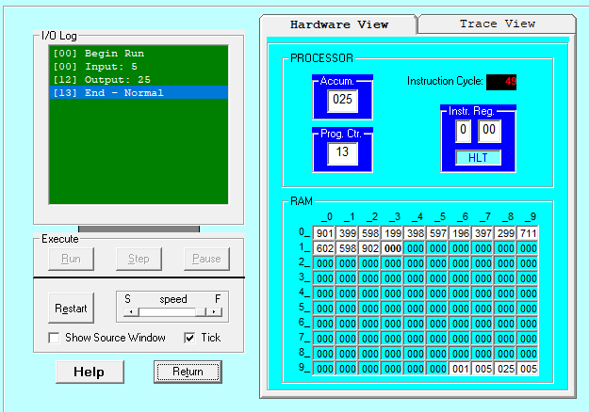

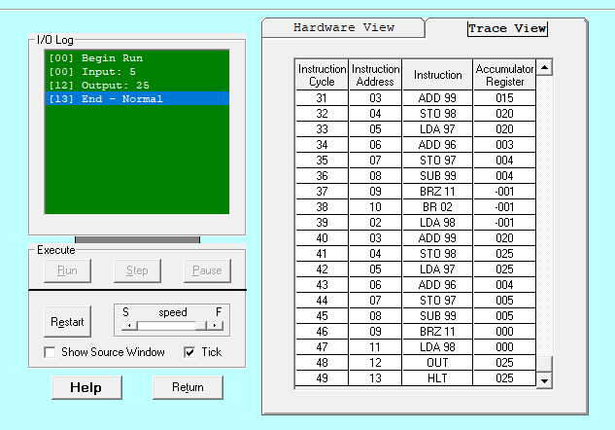

**Task No 2:** Write a VVM program which take an integer input and display table of that integer.

**INPUT:**

in

sto 90

lda 98

add 90

sto 98

lda 96

add 95

sto 96

sub 97

brp 11

br 12

hlt

lda 98

out

br 02

*95

dat 001

dat 000

dat 011

dat 000

**OUTPUT**

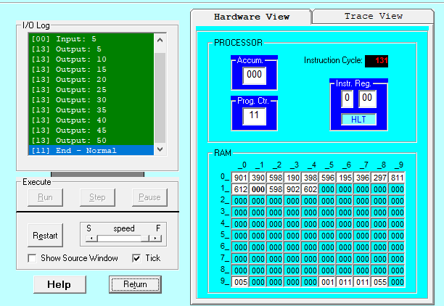

**HARDWARE VIEW:**

**TASK # 03:** Print number until the number is positive.

**INPUT:**

in

sto 99

lda 99

brp 05

hlt

out

br 00

**OUTPUT:**

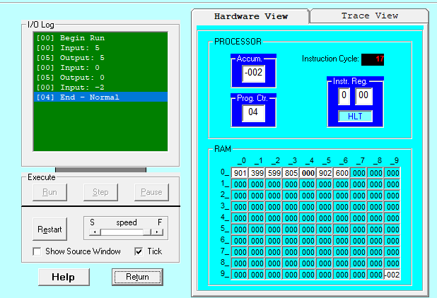

**HARDWARE VIEW:**

